Tentative Annual MURI Review Meeting Schedule
Montgomery Knight Building 317
February 6th, 2013

9:00am Brief Overview of MURI Research Status (P. Tsiotras - GT)
9:15am “Sampling-Based Algorithms for Continuous-Time POMDPs”
(E. Frazzoli , J.-h. Jeon, P. Chaudhari – MIT)

10:00am “On Connections Between Sampling-Based PP Algorithms and Asynchronous VI” (P. Tsiotras, O. Arslan – GT)

10:45am “Planning Trajectory Distributions, Not Just Trajectories, in the Face of Danger ” (E.Feron, E. Doidot – GT)

11:30am “Multi-resolution Semantic Scene Understanding from Monocular Vision”
(J. Rehg – GT)

12:15pm Lunch
1:30pm “Towards Bio-inspired Real-time Perception ” (F. Dellaert – GT)
2:15pm “TBD” (L. Itti , A. Borji– USC)
3:00pm “Threat Assessment and Shared Human-Machine Control of Semi-Autonomous Vehicles” (K. Iagnemma – MIT)
3:45pm Discussion (All)
4:30pm Adjourn

See next page of some additional instructions.

The Montgomery Knight Building is the main building of the School of Aerospace Engineering at Georgia Tech. It is located at the edge of the GaTech campus, right across the Coca-Cola HQ building at North Avenue. The official address for mapquest and googlemap searches is 270 Ferst Dr, Atlanta, GA 30332-1050.
The MK-317 conference room is on the 3rd building (where the business office is).
The easiest way to reach the GaTech campus is by taxi (approx. 20min drive, $20). If you take the metro (MARTA) from the airport you need to get-off at North Station Avenue (Red Line). The school is within 10min walk from there.
Useful telephone numbers in case of need: (404) 894-9526 (main AE office no)
(404) 894-9526 (my office no)
(404) 518-6398 (my cell no)

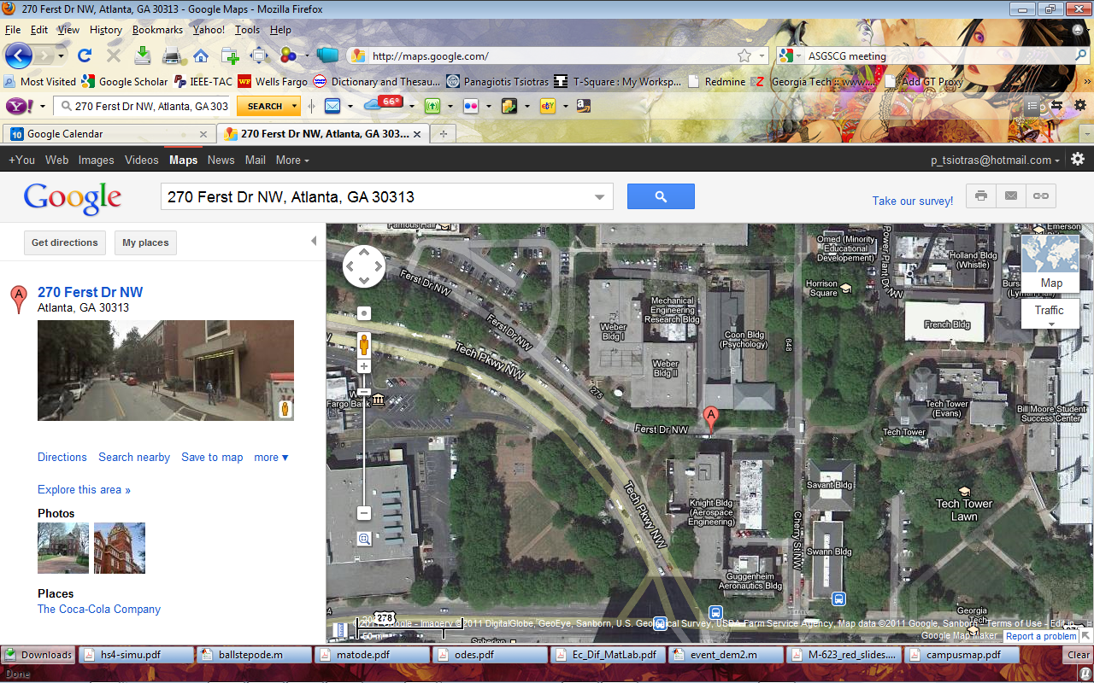

I will arrange for remote web-conferencing participation for individuals who would like to attend the meeting, but are not able to be there in person. Please send me the email(s) of any individuals who want to attend remotely so that I can forward them the link.

